

# Tribhuvan University

Faculty of Humanities and Social Science

Bhaktapur Multiple Campus

**Dudhpati-1, Bhaktapur**

**Lab Report on Tally.EPR 9**

|  |  |
| --- | --- |
| **Submitted By:**  “Sujan Tamang” "60" "B"  BCA 2nd Semester | **Submitted To:**  “Gopi Bhandari”  “Faculty of Humanities and Social Science” |

## ACKNOWLEDGEMENT

This lab report is especially assigned by the academic institution to the students of BCA 2nd semester for the partial fulfilment of the course and designed for the systematic and accurate use of accounting software i.e. **‘TALLY’**. For successful completion of this lab report there are various hands to help me out to whom I am greatly thankful.

I would like to thank BCA coordinator **Mr. Madan Nath** sir who granted our project work by understanding the needs of students. I am highly indebted to my subject teacher **Mr. Gopi Bhandari** sir for his guidance and constant supervision as well as for providing necessary information regarding the project & also for the support in completing the lab report. Similarly, I am thankful to the institution and faculty management for providing essential resources and remarkable support in this report. Lastly, I would express heartfelt gratitude to the TU board for innovation of such a wonderful course structure which can surely help to enhance the skill and career of student’s ahead in future

Sujan Tamang

BCA Second Semester Roll no: 60

**Table of Contents**

Introduction to Tally 1

Features 1

Uses of Tally 1

Tally Interface 2

Tally Home Screen 2

Accounts info 3

Inventory info 4

Creating a Company 4

Creating accounting Ledgers 5

Voucher Entry 6

Posting into Journals 6

Receipts 7

Payments 7

Contra 8

Purchase 9

Sales 9

Trial Balance 10

Profit and loss account 10

Balance sheet 11

# Shortcut keys for tally

Ctrl + A: Save Alt + Fl: Details

Alt + F3: Switch to Company info Esc: Switch to Gateway of tally Alt + C: Create

Alt + D: Delete Company, entries or anything Alt + P: To print the ledger

## Introduction to Tally

Tally is an accounting program for recording and identifying accounting transactions. It aids in the organization of accounting transactions. Rather than storing accounting entries in bulky books that can be damaged, Tally makes the accounting process digital and more secure. Tally makes it easier to keep track of entries. All accounting operations, such as journals, ledgers, trial balances, and final accounts, can be accommodated. Similarly, it eliminates the need for time-consuming calculations because Tally can compute entered data, so all that is required is to enter the data.

Tally accounting software also comes with drill down options, which can track every detail of transaction. It helps in maintaining simple classification of accounts, general ledger, accounts receivable and payable, bank reconciliation, etc.

## Features

Tally has the following features:

1. Its innovative voucher entry method allows for a wide range of transactions.
2. Users can have endless periods and budgets thanks to its auditing capabilities.
3. Multiple ledgers, such as General, Sales, and Purchase, are combined into a single ledger.
4. Because many companies involved in international trade perform transactions, it is progressively adjusting to encompass the use of numerous currencies.
5. It allows the user to manage all receivable and payable billing information from top to bottom.

## Uses of Tally

Tally can be used everywhere that requires accounting. From little small stores to education institutes to huge corporations, it is used. It can be implemented in any company that conducts financial transactions.

## Tally Interface

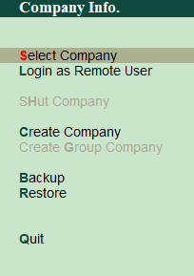Once Tally ERP 9 is open, The Company Info interface will appear. It includes the following features:

1. Select Company
2. Login as Remote User.
3. Create a company.
4. Backup.
5. Restore.

This tab allows you to create as many companies as needed as well as select created companies.

*Some of the tally interfaces are shown below*

## Tally Home Screen

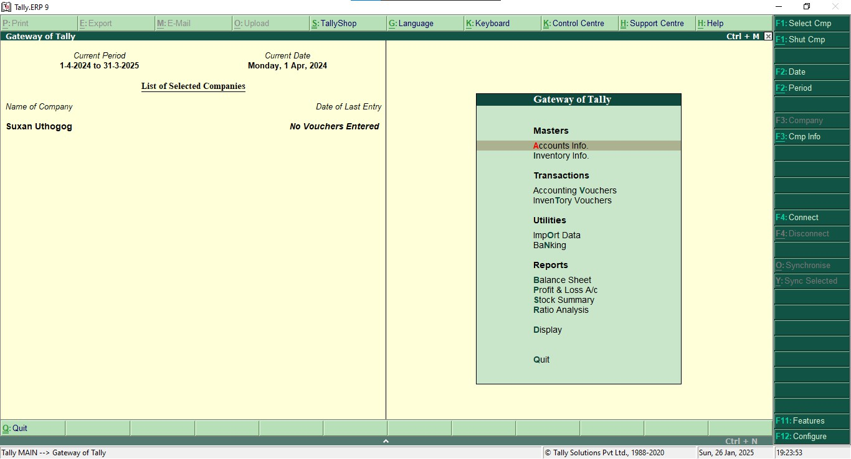

Tally's home screen is shown in the diagram above. It displays the possibilities for a number of Tally entries. On the home screen, you'll find Accounts Info, Accounting Vouchers, Import Data, Banking, Balance Sheet, Profit and Loss a/c, Ratio Analysis, Analysis and Verification, Display, and Quit.

## Accounts info

Groups, Ledgers, Vouchers, and other choices are available in this section. It allows you to see the information from the ledgers and vouchers you've input. Groups, Ledgers, and other options all have their own displays and functionalities.

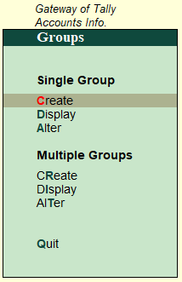The Group function can be used to enter data into accounts for groups. A desk, for example, fits under furniture and is recorded

in the Group compartment.

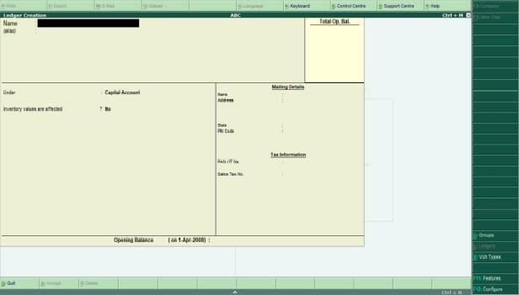The Ledger function can be used to generate new ledger accounts for use in future entries and vouchers. Following the selection of this function, a ledger can be made in the Create section, which displays the supplied interface.

## Inventory info

Stock Groups, Stock Items, Units of Measure, Voucher Types, and Copy Allocation Details are all available in Inventory Info.

## Creating a Company

1. Go to Gateway of Tally
2. In Company info we can see Create Company
3. Select it, Company creation window will appear.
4. At last, the message Accept? Yes/ No will Displayed.
5. Press Enter or Y to save the details Name: Suzan Karkhana

Mailing Address: Nuwakot, Nepal Contact No: 01-6638441

Email: [karkhanasuzan@gmail.com](mailto:karkhanasuzan@gmail.com)

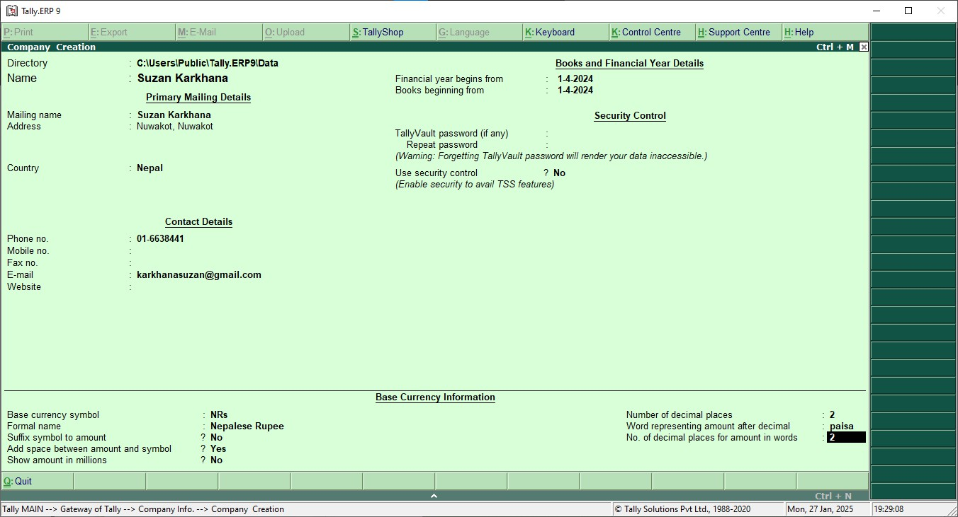

## Creating accounting Ledgers

* Go to gateway of tally
* Selects Account Info and Click on Create
* Enter name of account and fill other data.

**Ledger**

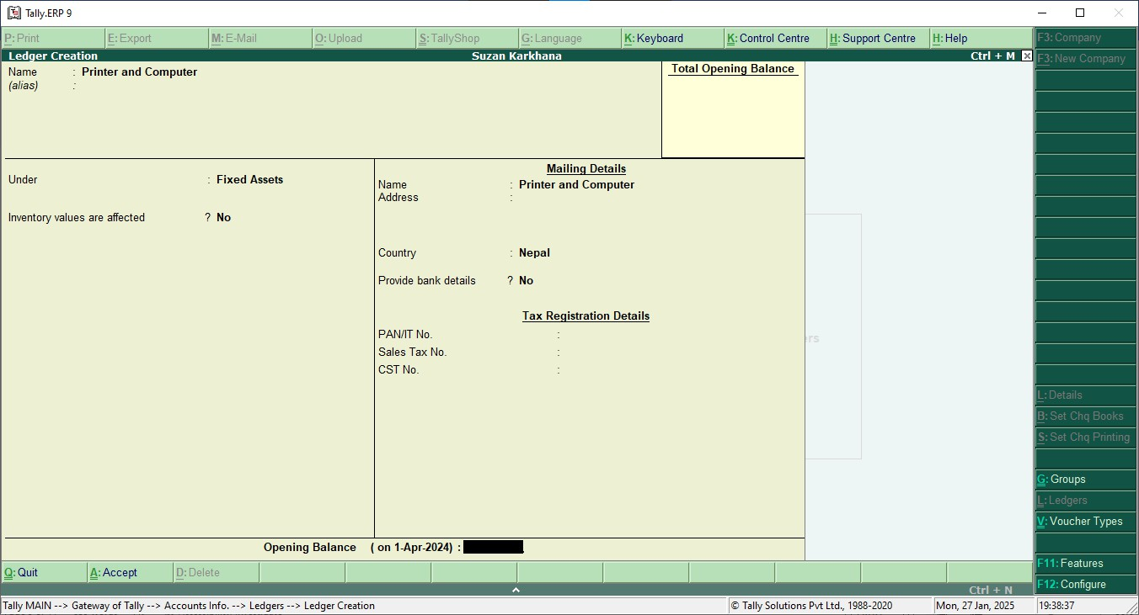

**List of Ledger**

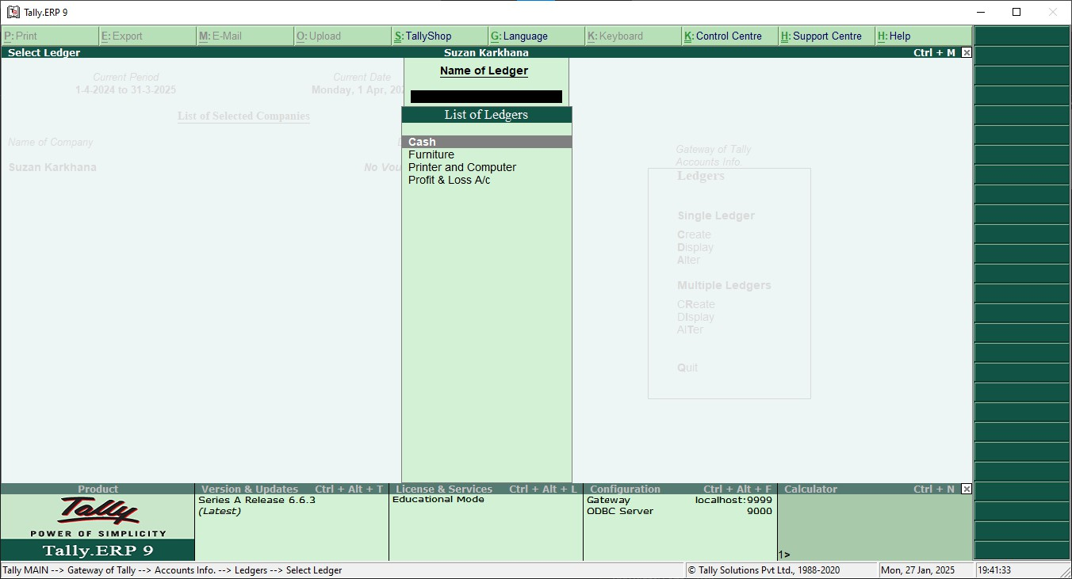

***Note: While making leger, by default two ledger are created in tally (i.e. cash A/C and Profit and loss A/C).***

## Voucher Entry

In accounting terms, a voucher is a document containing the details of a financial transaction. For example, a purchase invoice, a sales receipt, a petty cash docket, a bank interest statement and so on. For every such transaction made, a voucher is used to enter details into the ledger to update the financial position of the company.

## Posting into Journals

First you have to configure the voucher entry,

1. Press F12 and select the voucher Entry
2. Enter No in use single entry mode for payment and enter yes in use debit / credit instead of to/by

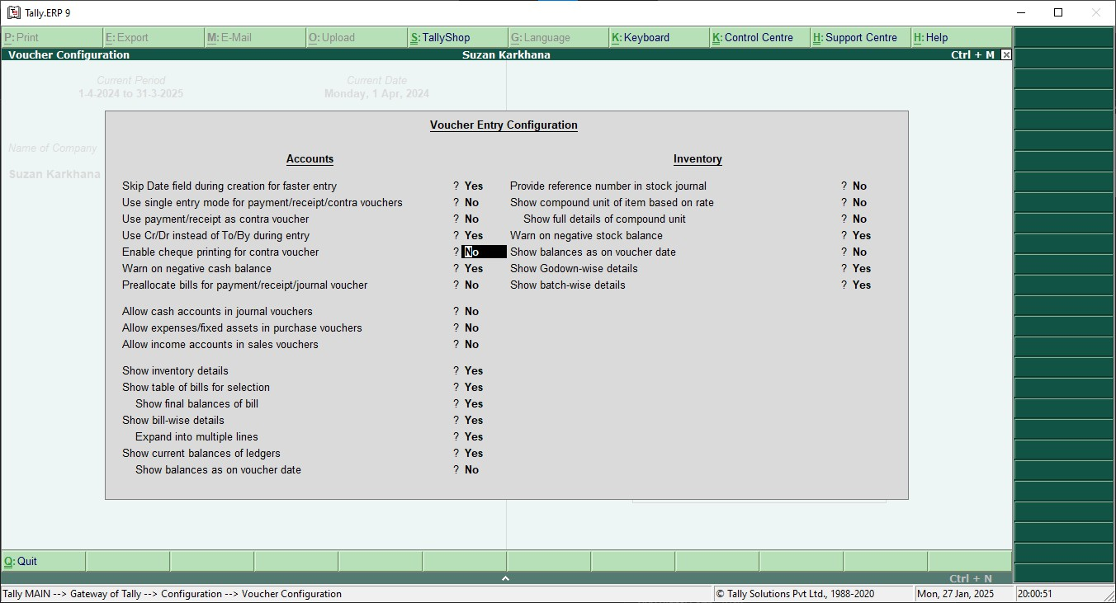

## Receipts

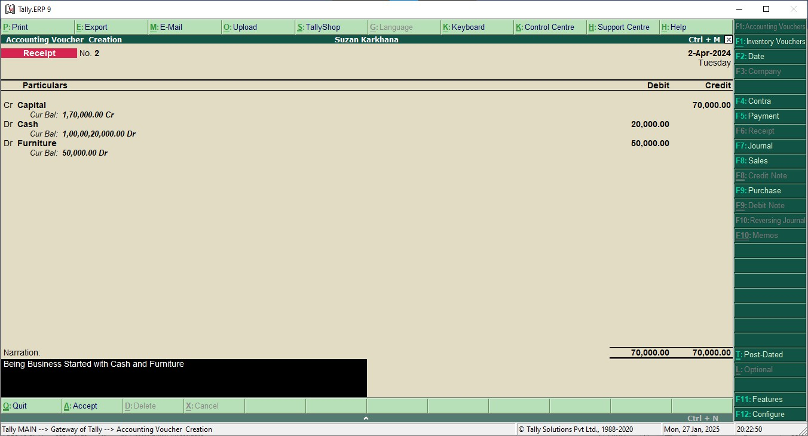Being business started with cash Rs 20000 and Furniture Rs 50000

## Payments

Rent paid to house owner Rs 5000

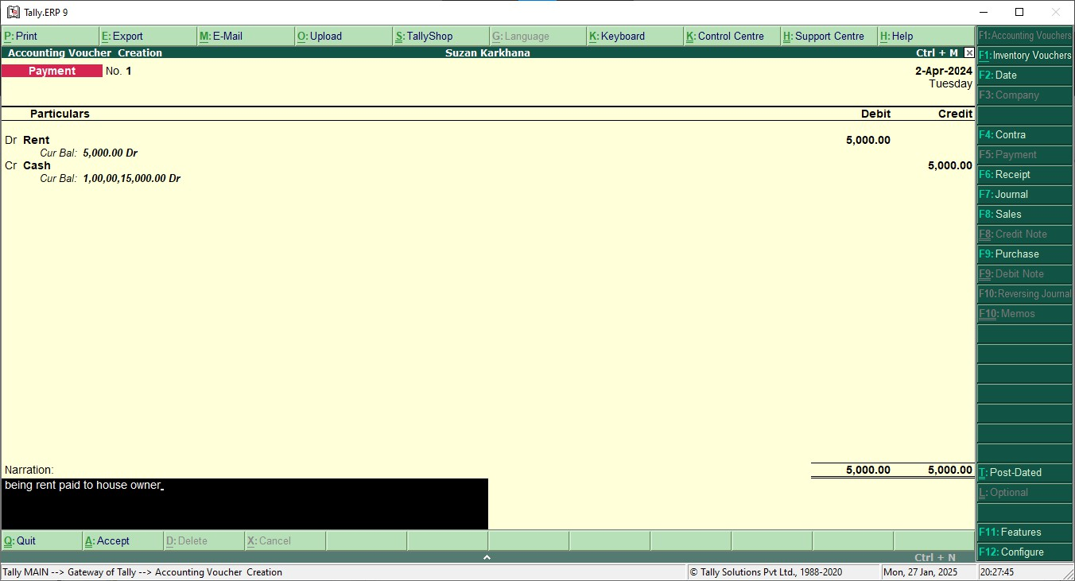

## Contra

A Contra Entry is an entry in a business book of accounts, indicating transfer of funds from:

* Cash account to bank account
* Bank account to cash account
* One bank account to another bank account
* Go to Gateway of Tally > Accounting Vouchers> F4: Contra

Cash Rs 50000 deposited into Mero Bank.

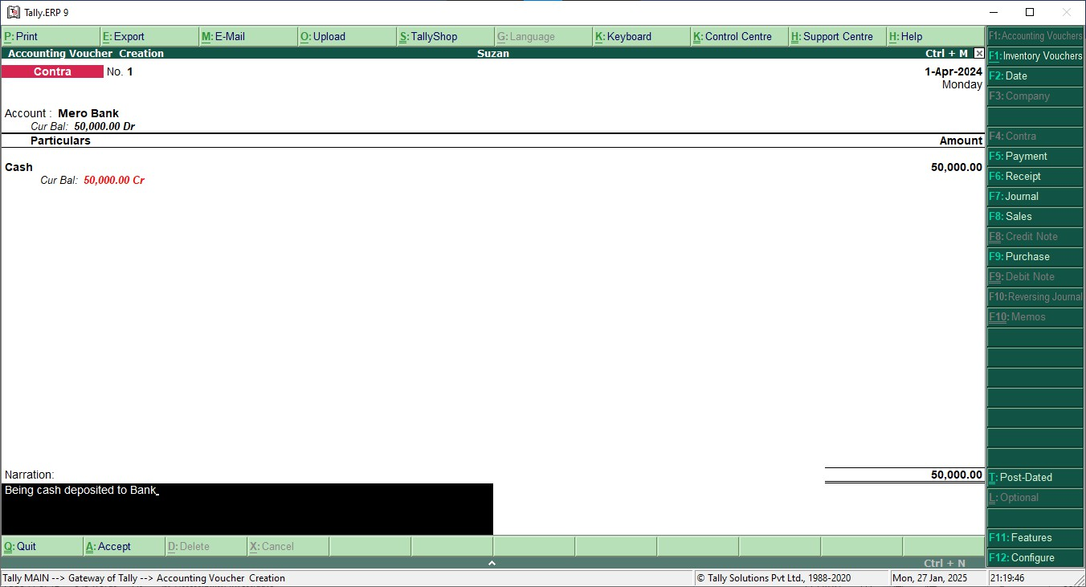

## Purchase

Goods Purchased Rs 20000

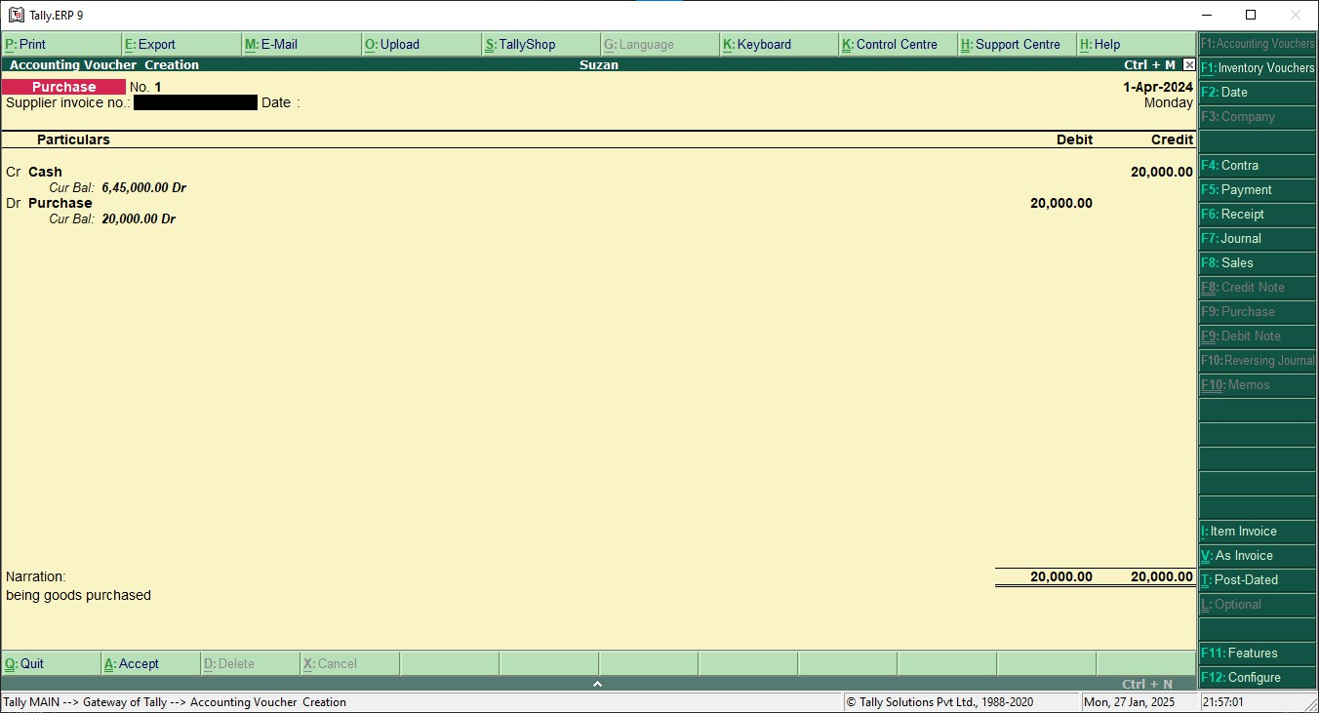

## Sales

Goods sold costing Rs 5000 on cash

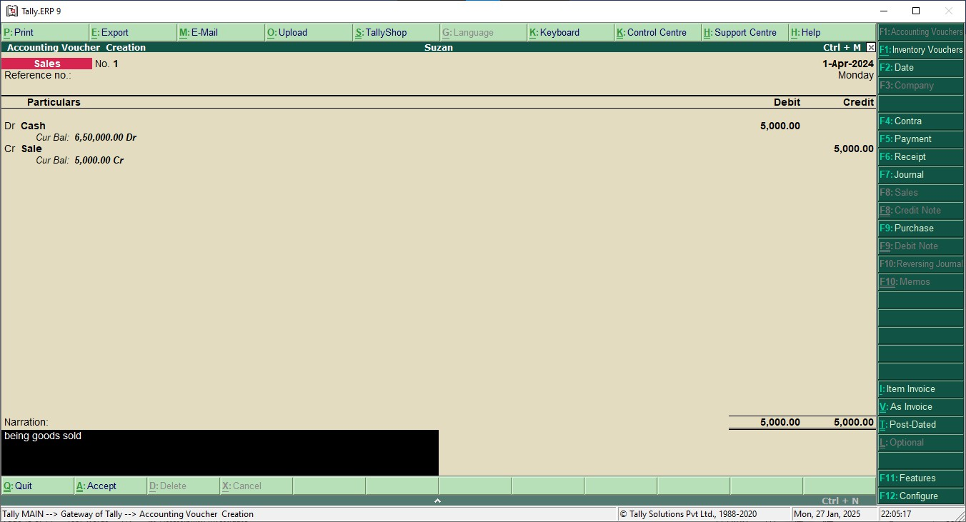

## Trial Balance

Showing the transaction into the trial balance.

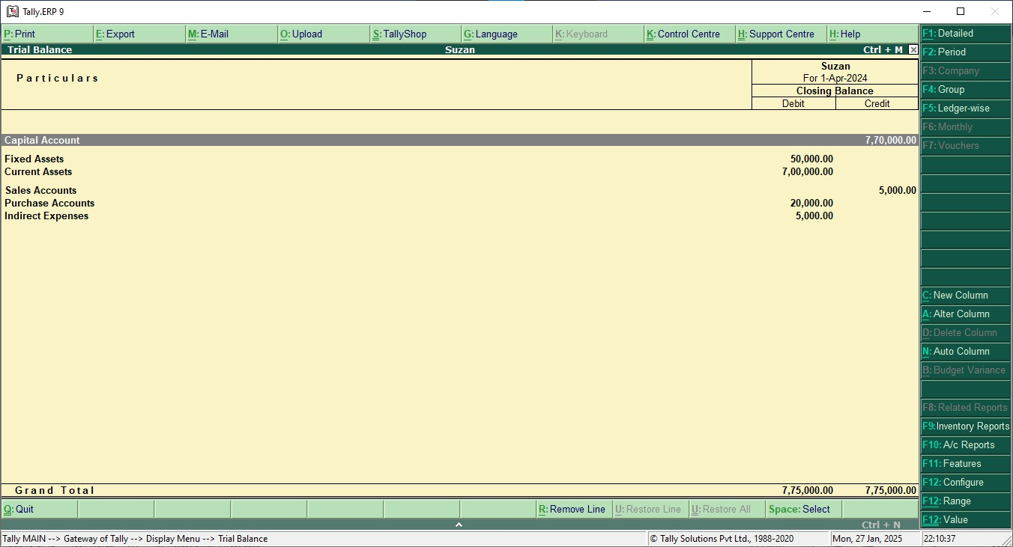

## Profit and loss account

Showing the transaction into the profit and loss account.

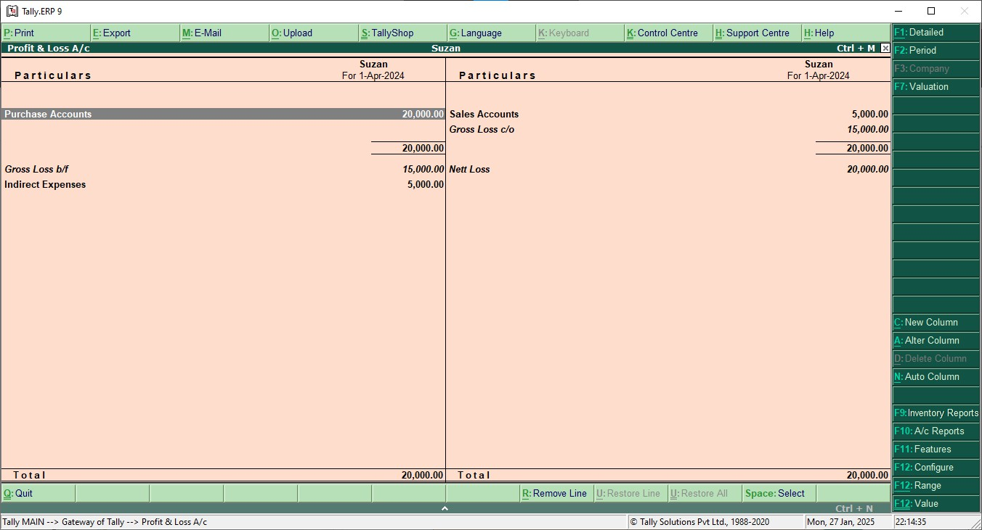

## Balance sheet

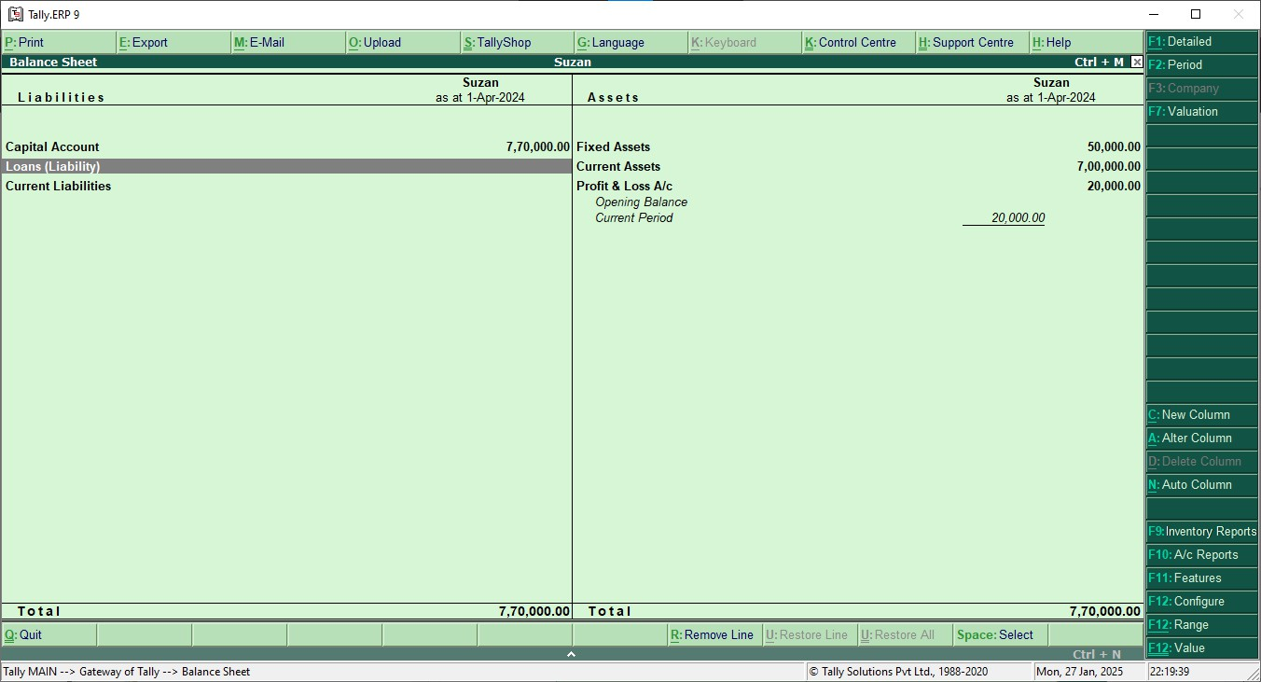Showing the transaction into the balance sheet